IP Project 1

Shuowen Wei

2012.2.13

Problem 1.

We let **d** vary from 0.2 to 0.8 and get the corresponding value of **b** showed in the graph below:

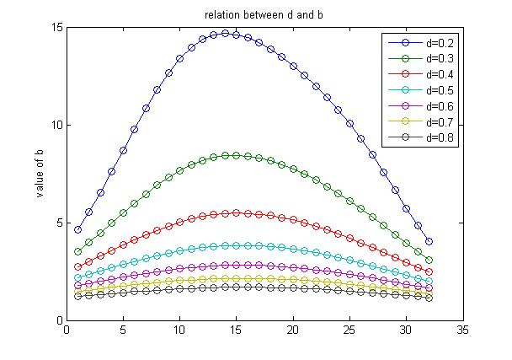

The table below shows the corresponding maximum and minimum value of **b** with respect to different depth **d**:

|  |  |  |  |  |  |  |  |
| --- | --- | --- | --- | --- | --- | --- | --- |
| **d** | 0.2 | 0.3 | 0.4 | 0.5 | 0.6 | 0.7 | 0.8 |
| Max **b** | 14.666 | 8.427 | 5.479 | 3.829 | 2.817 | 2.152 | 1.693 |
| Min **b** | 4.030 | 3.096 | 2.460 | 1.997 | 1.647 | 1.376 | 1.162 |

Obviously we can see that when **d** is larger, then the max and min value of **b** is smaller, and the curve of **b**, from the graph, becomes more smoother and narrower.

Problem 2.

We fix **d**=0.5, let **n** vary from 5 to 50 and get the corresponding condition number of matrix **A** in the graph below:

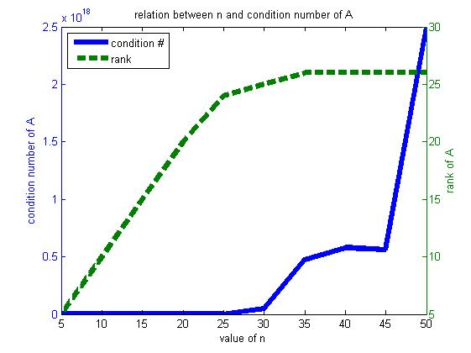

Even when **n**=5 very small, the condition number of matrix A is 93.74, very big. Thus, we also compute the rank of **A** according to each **n** and show them in the table below:

|  |  |  |  |  |  |
| --- | --- | --- | --- | --- | --- |
| **n** | 5 | 10 | 15 | 20 | 25 |
| rank(**A**) | 5 | 10 | 15 | 20 | 24 |
| **n** | 30 | 35 | 40 | 45 | 50 |
| rank(**A**) | 25 | 26 | 26 | 26 | 26 |

The output **A** should be n-by-n matrix and Toeplitz, but we can see that **A** becomes rank deficient when n=25 (or between 20 and 25, to be precise).

Problem 3.

Now, we keep **n** fixed at 32, and then let **d** vary from 0. 1 to 1 and compute the corresponding condition number of matrix **A** (which is n-by-n matrix), the results are showed in the graph below:

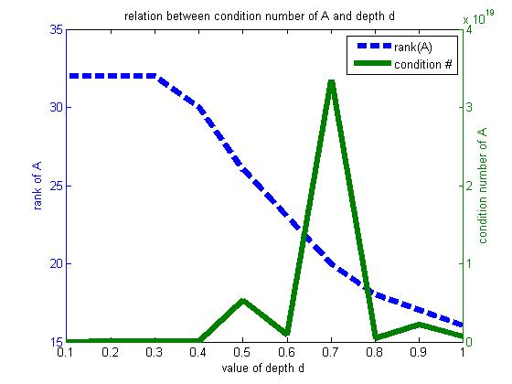

When the depth **d** is small, say less than 0.3, the matrix **A** is still full rank, i.e. rank(**A**) equals **n** which is fixed at 32, and we have the smallest value of the condition number of **A**, min(cond(**A**))=2524.04, which is also very large. When **d** is greater than 0.3, then **A** becomes rank deficient, and theoretically speaking, the condition number of a rank deficient matrix is $∞$.

Problem 4.

We set **n**=32, **example**=2 and **d**=0.5, under the compact format in Matlab, by using the backslash commend “**\**” we get the relative error of **xc** is 12.8303.

This large error implies the result **xc** computed by ***backslash*** commend is very far away from the true solution **x**, this is because when **n**=32, **d**=0.5, based on the observations from problem 2 and 3, we already know that the output matrix **A** is rank deficient and with super large condition number, thus for this an ill-conditioned problem, directly computing the solution by ***backslash*** commend will make the result very unstable. In the coming problem 5 we will try to use the **truncated SVD** solve such ill-conditioned problem.

Problem 5.

Under the same set of the parameters with problem 4, we use ***semilogy*** to plot the singular values of matrix **A** below, from the left of the graph we can see how these singular values of **A** decay:

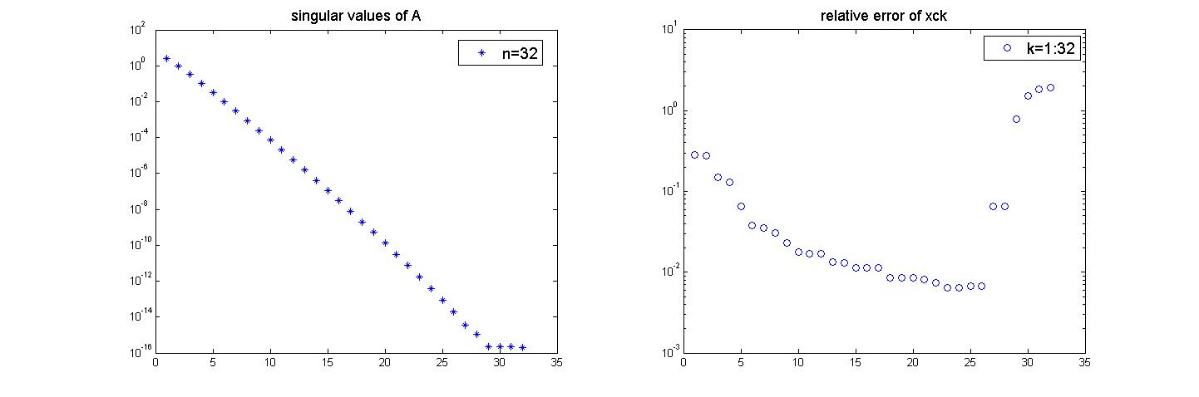

The **truncated SVD** ktsvd.m can be found in the appendix, and we tried every **k** from 1 to **n**=32 to find which one minimizes the relative error of **xck**, also showed by ***semilogy*** at the right of the graph above. It turned out be k=24 has the minimum relative error equals 0.006458.

When **k**=16, the relative error is 0.011396.

Problem 6.

(1).

We set **n**=32, **d**=0.5 and compute the solution for the normal equation by ***backslash*** and get the each relative error for each $λ$ as follows:

|  |  |  |  |  |
| --- | --- | --- | --- | --- |
| $$λ$$ | 0.0001 | 0.001 | 0.01 | 0.1 |
| relative error | 0.0203 | 0.0314 | 0.0466 | 0.1249 |

And obviously, $λ$ = 0.0001 gives the smallest relative error in this solution method.

(2).

With the same parameter set as (1), we compute least squares problem by ***lsqlin*** and get the each relative error for each $λ$ as follows:

|  |  |  |  |  |
| --- | --- | --- | --- | --- |
| $$λ$$ | 0.0001 | 0.001 | 0.01 | 0.1 |
| relative error | 0.0203 | 0.0314 | 0.0466 | 0.1249 |

And also, $λ$ = 0.0001 gives the smallest relative error in this solution method. As a matter of fact, these two methods are equivalent.

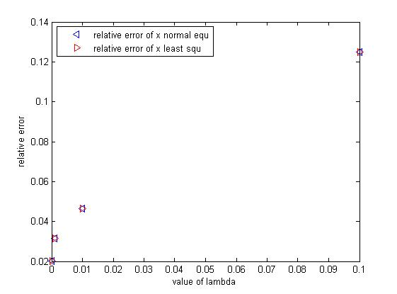

Problem 7.

We set **n**=32, **d**=0.5 and **example**=2 for the whole problem 7:

(1) repeat problem 4 by ***bn*** vectors;

|  |  |  |  |  |  |
| --- | --- | --- | --- | --- | --- |
| k | 5 | 10 | 12 | 14 | 16 |
| noise level | 1.23065e-12 | 1.23065e-07 | 1.23065e-05 | 0.00123 | 0.12306 |
| relative error | 5.36527e+05 | 5.36529e+10 | 5.36529e+12 | 5.36529e+14 | 5.36529e+16 |

From the large relative errors, we can still easily see that the results computed by ***backslash*** commend is very far away from the true solutions, which implies that directly using ***backslash*** commend is very unstable in solving this ill-conditioned problem.

(2) repeat problem 5

We already showed the singular values of matrix **A** in in graph in problem 5, now on each different level of noise, we compute each relative error of each solution got by each truncated position from 1 to 32, showed in the graph below:

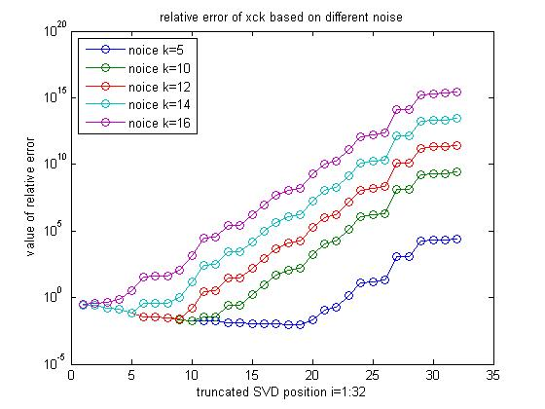

And we list the best truncated SVD position along with its corresponding minimum value of relative error in the table below:

|  |  |  |  |  |  |
| --- | --- | --- | --- | --- | --- |
| k | 5 | 10 | 12 | 14 | 16 |
| noise level | 1.23065e-12 | 1.23065e-07 | 1.2307e-05 | 0.00123 | 0.12306 |
| Truncated position | 18 | 10 | 9 | 5 | 1 |
| relative error | 0.0086 | 0.0178 | 0.0253 | 0.0724 | 0.2915 |

Note that every time we run the program (listed in the appendix), the results we may get maybe a little different, that’s is because the commend ***randn*** will randomly generate a sequences of numbers under Gaussian Distribution, that’s where the differences come from.

(3) repeat problem 6-1

We solve the normal equation by ***backslash*** and get the minimum relative errors for each $λ$ based on different noise are as follows:

|  |  |  |  |  |  |
| --- | --- | --- | --- | --- | --- |
| k | 5 | 10 | 12 | 14 | 16 |
| noise level | 1.23065e-12 | 1.23065e-07 | 1.2307e-05 | 0.00123 | 0.12306 |
| $$λ$$ | 0.0001 | 0.0001 | 0.001 | 0.1 | 0.1 |
| minimum relative error | 0.0203 | 0.0210 | 0.0356 | 0.1336 | 2.2398 |

For problem 6-2

We solve the normal equation by ***backslash*** and get the minimum relative errors for each $λ$ based on different noise are as follows:

|  |  |  |  |  |  |
| --- | --- | --- | --- | --- | --- |
| k | 5 | 10 | 12 | 14 | 16 |
| noise level | 1.23065e-12 | 1.23065e-07 | 1.2307e-05 | 0.00123 | 0.12306 |
| $$λ$$ | 0.0001 | 0.0001 | 0.001 | 0.1 | 0.1 |
| minimum relative error | 0.0203 | 0.0210 | 0.0356 | 0.1336 | 2.2398 |

As mentioned above in problem5, the two methods are equivalent and thus the results listed in the two tables are exactly the same.

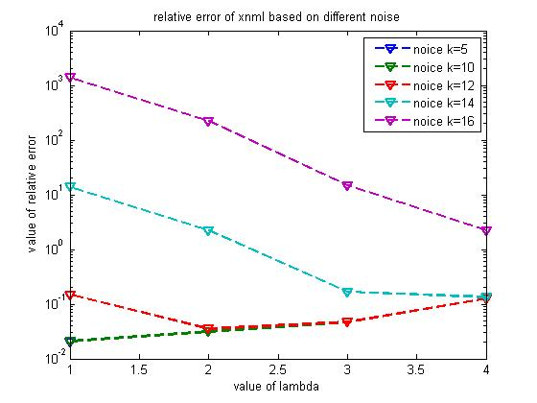

Appendix

Problem: 1.m

clc;clear

format compact

format short

b=[];

d=[0.2:0.1:0.8];

for i=1:length(d)

[A,bb,x]=gravity(32,2,0,1,d(i));

b=[b,bb];

end

plot(b,'-o')

legend('d=0.2','d=0.3','d=0.4','d=0.5','d=0.6','d=0.7','d=0.8')

ylabel('value of b')

title('relation between d and b')

max_b=max(b);

min_b=min(b);

Problem: 2.m

clc;clear

format compact

format long

n=[5:5:50]

condA=[];

rankA=[];

for i=1:length(n)

[A,bb,x]=gravity(n(i),2,0,1,0.5);

condA=[condA,cond(A)];

rankA=[rankA,rank(A)];

end

condA;

rankA;

%p=plot(n,condA,'*')

[AX,H1,H2]=plotyy(n,condA,n,rankA,'plot');

xlabel('value of n')

title('relation between n and condition number of A')

set(get(AX(1),'Ylabel'),'String','condition number of A')

set(get(AX(2),'Ylabel'),'String','rank of A')

set(H1,'LineStyle','-','LineWidth',5)

set(H2,'LineStyle','--','LineWidth',5)

legend('condition #','rank','Location','NorthWest')

Problem: 3.m

clc;clear

format compact

format long

condA=[];

rankA=[];

d=[0.1:0.1:1];

for i=1:length(d)

[A,bb,x]=gravity(32,2,0,1,d(i));

condA=[condA,cond(A)];

rankA=[rankA,rank(A)];

end

[AX,H1,H2]=plotyy(d,rankA,d,condA,'plot');

xlabel('value of depth d')

title('relation between condition number of A and depth d ')

set(get(AX(1),'Ylabel'),'String','rank of A')

set(get(AX(2),'Ylabel'),'String','condition number of A')

set(H1,'LineStyle','--','MarkerEdgeColor','b','LineWidth',5)

set(H2,'LineStyle','-','MarkerEdgeColor','r','LineWidth',5)

legend('rank(A)','condition #','Location','NorthEast')

Problem: 4.m &5.m

clc;clear

format compact

n=32;

d=0.5;

[A,b,x]=gravity(n,2,0,1,d);

% question 4

xc=A\b;

rlerrxc=norm(xc-x)/norm(x)

% question 5

[U,S,V]=svd(A);

subplot(1,2,1); semilogy(diag(S),'*')

title('singular values of A')

legend('n=32')

rlerrxck=[];

for k=1:n

xck=ktsvd(A,b,n,k);

new=norm(xck-x)/norm(x);

rlerrxck=[rlerrxck,new];

end

subplot(1,2,2); semilogy(rlerrxck,'o')

title('relative error of xck')

legend('k=1:32')

minvalue=min(rlerrxck')

k=find(rlerrxck==minvalue)

rlerrxck(16)

The ktsvd.m

function xck = ktsvd(A,b,n,k)

xck=zeros(n,1);

[U,S,V] = svd(A);

for i=1:k

xck=xck+(U(:,i)'*b/S(i,i))*V(:,i);

end

Problem: 6.m

clc;clear

format compact

lambda=[0.0001,0.001,0.01,0.1];

n=32;

d=0.5;

[A,b,x]=gravity(n,2,0,1,d);

% question 6-1

rlerrxmnl=[];

for i=1:length(lambda)

xnml=(A'*A+lambda(i)^2.*eye(n))\(A'*b);

new=norm(xnml-x)/norm(x);

rlerrxmnl=[rlerrxmnl,new];

end

% question 6-2

rlerrxt=[];

for i=1:4

c=[A;lambda(i)*eye(n)];

d=[b;zeros(n,1)];

xt=lsqlin(c,d);

new=norm(xt-x)/norm(x);

rlerrxt=[rlerrxt,new];

end

plot(lambda,rlerrxmnl,'b<',lambda,rlerrxt,'r>')

legend('relative error of x normal equ','relative error of x least squ','Location','NorthWest')

xlabel('value of lambda')

ylabel('relative error')

Problem: 7.m

clear;clc

format compact

n=32;

d=0.5;

[A,b,x]=gravity(n,2,0,1,d);

k=[5 10 12 14 16];

s=randn(32,1);

noise=eps*(10.^k);

%repeat question 4

rlerrxcn=[];

noiselevel=[];

for i=1:5

bn=b+s.*noise(i);

new1=norm(noise(i))/norm(b);

noiselevel=[noiselevel,new1];

xcn=A\bn;

new2=norm(xcn-x)/norm(x);

rlerrxcn=[rlerrxcn,new2];

end

%repeat question 5

[U,S,V]=svd(A);

rlerrxck=[];

positionk=[];

for i=1:5

bn=b+s.*noise(i);

rlerr=[];

for k=1:32

xckn=ktsvd(A,bn,n,k);

new=norm(xckn-x)/norm(x);

rlerr=[rlerr;new];

end

rlerrxck=[rlerrxck,rlerr];

minvalue=min(rlerrxck(:,i));

locate=find(rlerrxck(:,i)==minvalue);

positionk=[positionk,locate];

end

min(rlerrxck)

positionk

semilogy(rlerrxck,'-o')

title('relative error of xck based on different noise')

legend('noice k=5','noice k=10','noice k=12','noice k=14','noice k=16','Location','NorthWest')

xlabel('truncated SVD position i=1:32')

ylabel('value of relative error')

%repeat question 6-1

lambda=[0.0001,0.001,0.01,0.1];

rlerrxmnl=[];

positionlmd=[];

for i=1:5

bn=b+s.*noise(i);

rlerr=[];

for j=1:4

xnml=(A'*A+lambda(j)^2.*eye(n))\(A'*bn);

new=norm(xnml-x)/norm(x);

rlerr=[rlerr;new];

end

rlerrxmnl=[rlerrxmnl,rlerr];

minvalue=min(rlerrxmnl(:,i));

locate=find(rlerrxmnl(:,i)==minvalue);

positionlmd=[positionlmd,locate];

end

min(rlerrxmnl)

positionlmd

lambda(positionlmd)

%repeat question 6-2

rlerrxt=[];

positionlmd=[];

for i=1:5

bn=b+s.*noise(i);

rlerr=[];

for j=1:4

c=[A;lambda(j)*eye(n)];

d=[bn;zeros(n,1)];

xt=lsqlin(c,d);

new=norm(xt-x)/norm(x);

rlerr=[rlerr;new];

end

rlerrxt=[rlerrxt,rlerr];

minvalue=min(rlerrxt(:,i));

locate=find(rlerrxt(:,i)==minvalue);

positionlmd=[positionlmd,locate];

end

min(rlerrxt)

positionlmd

lambda(positionlmd)

semilogy(rlerrxmnl,'--v','LineWidth',2)

title('relative error of xnml based on different noise')

legend('noice k=5','noice k=10','noice k=12','noice k=14','noice k=16','Location','NorthEast')

xlabel('value of lambda')

ylabel('value of relative error')